**LGM-30 Minuteman III**

[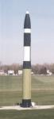](http://www.globalsecurity.org/wmd/systems/images/us_nuke_minuteman3_01.jpg)[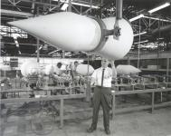](http://www.globalsecurity.org/wmd/systems/images/us_nuke_minuteman_02.jpg)[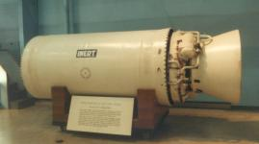](http://www.globalsecurity.org/wmd/systems/images/us_nuke_minuteman3_stage2_engine_01.jpg)[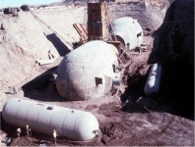](http://www.globalsecurity.org/wmd/systems/images/mm3-maf11.jpg)[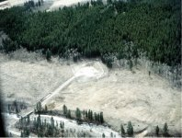](http://www.globalsecurity.org/wmd/systems/images/mm3-site61.jpg)[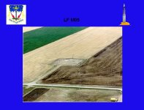](http://www.globalsecurity.org/wmd/systems/images/mm3-site81.jpg)[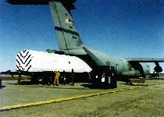](http://www.globalsecurity.org/wmd/systems/images/mm3-deploy.jpg)[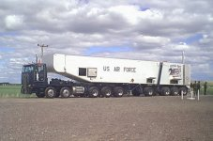](http://www.globalsecurity.org/wmd/systems/images/image026.jpg)[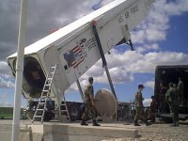](http://www.globalsecurity.org/wmd/systems/images/image017.jpg)[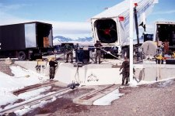](http://www.globalsecurity.org/wmd/systems/images/mm3-site21.jpg)[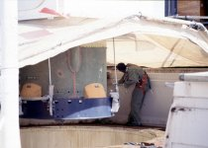](http://www.globalsecurity.org/wmd/systems/images/mm3-site51.jpg)[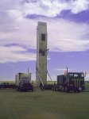](http://www.globalsecurity.org/wmd/systems/images/image084.jpg)[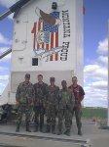](http://www.globalsecurity.org/wmd/systems/images/image011.jpg)[](http://www.globalsecurity.org/wmd/systems/images/image030.jpg)[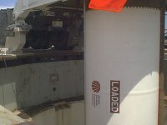](http://www.globalsecurity.org/wmd/systems/images/image077.jpg)[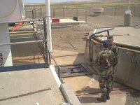](http://www.globalsecurity.org/wmd/systems/images/image078.jpg)[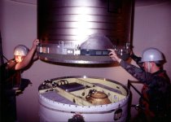](http://www.globalsecurity.org/wmd/systems/images/mm3-site41.jpg)[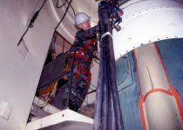](http://www.globalsecurity.org/wmd/systems/images/mm3-site11.jpg)[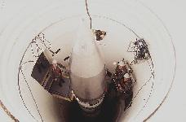](http://www.globalsecurity.org/wmd/systems/images/mm3-dfst9803326.jpg)[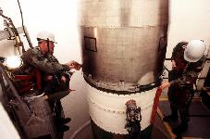](http://www.globalsecurity.org/wmd/systems/images/mm3-dfst9803333.jpg)[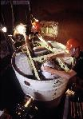](http://www.globalsecurity.org/wmd/systems/images/mm3-pbcs-dfst9806188.jpg)[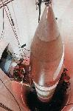](http://www.globalsecurity.org/wmd/systems/images/lgm-30-dvic441.jpg)[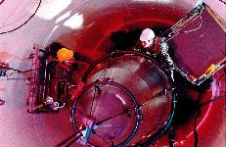](http://www.globalsecurity.org/wmd/systems/images/mm3-11.jpg)[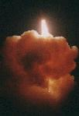](http://www.globalsecurity.org/wmd/systems/images/mm3-fote.jpg)[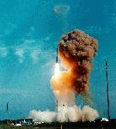](http://www.globalsecurity.org/wmd/systems/images/mm3-10.jpg)[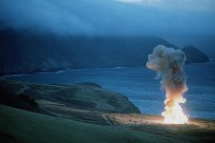](http://www.globalsecurity.org/wmd/systems/images/slide61.jpg)[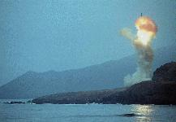](http://www.globalsecurity.org/wmd/systems/images/lgm-30-dvic442.jpg)[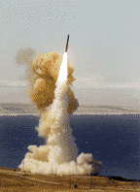](http://www.globalsecurity.org/wmd/systems/images/lgm_30.jpg)[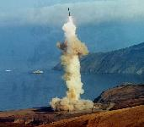](http://www.globalsecurity.org/wmd/systems/images/lgm-30-dvic440.jpg)[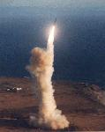](http://www.globalsecurity.org/wmd/systems/images/mm3-1.jpg)[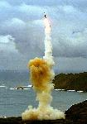](http://www.globalsecurity.org/wmd/systems/images/mm-pic-a.jpg)[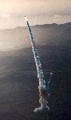](http://www.globalsecurity.org/wmd/systems/images/mm3-launch.jpg)[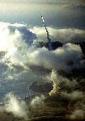](http://www.globalsecurity.org/wmd/systems/images/mm-pic-b.jpg)[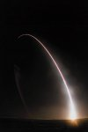](http://www.globalsecurity.org/wmd/systems/images/slide91.jpg)[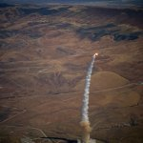](http://www.globalsecurity.org/wmd/systems/images/mm3-slide49.jpg)[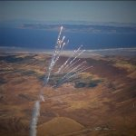](http://www.globalsecurity.org/wmd/systems/images/mm3-slide50.jpg)[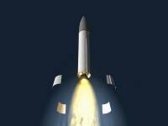](http://www.globalsecurity.org/wmd/systems/images/mm-3-art_space_0005.jpg)[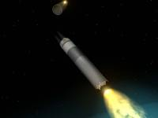](http://www.globalsecurity.org/wmd/systems/images/mm-3-art_space_0001.jpg)[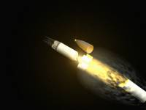](http://www.globalsecurity.org/wmd/systems/images/mm-3-art_space_0004.jpg)[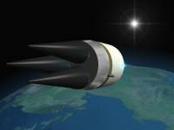](http://www.globalsecurity.org/wmd/systems/images/mm-3-art_space_0003.jpg)[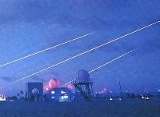](http://www.globalsecurity.org/wmd/systems/images/minutemaniii-kmr.jpg)[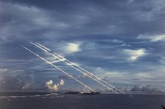](http://www.globalsecurity.org/wmd/systems/images/slide86.jpg)[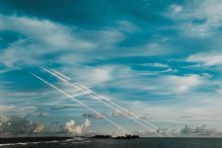](http://www.globalsecurity.org/wmd/systems/images/slide92.jpg)